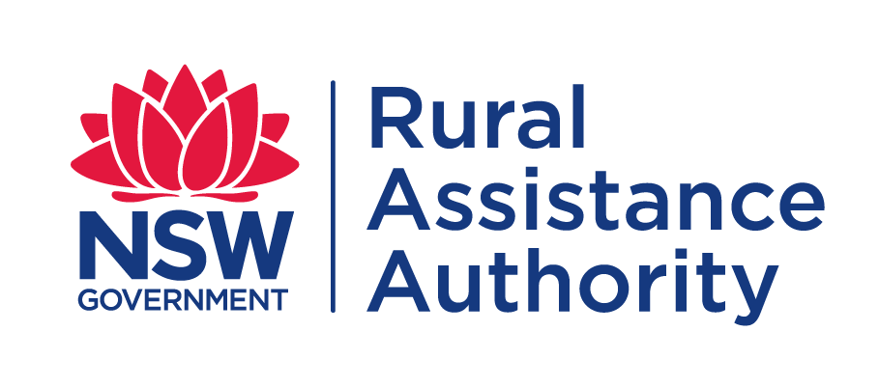 | CLAIM FORM for Round Three  TRANSPORT SUBSIDY  EMERGENCY DROUGHT RELIEF

Please submit copies of tax invoices

Have you applied previously for assistance from the NSW Rural Assistance Authority? | Yes | No
If you select ‘Yes’ please provide your 7-digit BP number, if available. | BP: 25

Have you previously applied for the Emergency Drought Relief Transport Subsidy?  If you are claiming additional invoices against an application that has already been approved for this round, please click this link or visit https://industrynsw.tfaforms.net/4635438  Or you can email your invoices to rural.assist@raa.nsw.gov.au with your BP number. | Yes | No

- ABOUT YOU
Applicant(s) Full Name(s) : |  |  | Date(s) of Birth
 |  |  | / /
 |  |  | / /
Full Property Address:
 |  | Postcode
Local Government Area (LGA) of property:
Local Land Service (LLS) of property:

Postal Address (If different to property address)
 |  | Postcode
Phone: | Mobile:
E-mail :

- ABOUT YOUR PRODUCTION BUSINESS
Trading name (if different from the legal / registered name):
ABN/ACN:

Under normal circumstances, more than 50% of my/our total gross income is derived from the business which is claiming.  If you select ‘No’ please attach a copy of your most recent taxation return(s) for your farm business. | Yes | No
My/our gross off-farm assets do not exceed $5,000,000 (excluding funds in a registered superannuation fund). | Yes | No

Select which best describes the nature of your business:
Beef | Dairy | Sheep | Poultry
Pigs | Cropping | Intensive livestock | Mixed Farming

- BANK ACCOUNT DETAILS
Please provide bank account details for payment of grant
Account Name:
Bank/Credit Union etc Name:
BSB : | Account No:

- PARTICULARS OF TRANSPORTATION COSTS
Transport of stock to agistment | A
Transport of stock from agistment | B
Transport of stock to sale or slaughter | C
Transport of fodder | D
Transport of water | E
Transport of fertilizer | F
Transport of farm chemicals | G
Transport of seed to farms | H
Transport of purchased stock to the farm business | I

Movt No | Type  (A, B, C, D E) | Date of Movement | Movement From | Movement To | Number of stock / tonnage | Stock/Fodder type | Loaded Distance (km) | Freight* costs ex GST (GST not payable)
 |  | / /
 |  | / /
 |  | / /
 |  | / /
 |  | / /
 |  | / /
 |  | / /
 |  | / /
 |  | / /
 |  | / /
 |  | / /
 |  | / /
 |  | / /
 |  | / /
 |  | / /
 |  |  |  |  |  |  | TOTAL
*For hired carrier or rail movements (where private vehicle is used insert PV)

- STATEMENTS
General Statement
Any person who knowingly and with intent to defraud the NSW Rural Assistance Authority or another person, files an application for assistance containing any materially false information, or conceals for the purpose of misleading information concerning any fact material thereto, commits a fraudulent act, which is a crime under the Crimes Act 1900 and subjects the person to criminal penalties

Privacy Statement
The information in this application is provided voluntarily and is being collected by the NSW Rural Assistance Authority for purposes related to the administration of the scheme of assistance under which you have applied, including the assessment of the effectiveness of the scheme. This may involve disclosing the information in this application to contractors engaged by the Authority or to either State or Commonwealth government agencies. We will supply you with details of those that we have disclosed information to, if you apply to us in writing. Information regarding your application may also be discussed and exchanged with the nominated contact persons listed by you in your application.
Not providing the information requested in this application or providing false or misleading or incomplete information may impact on the ability of the Authority to accurately assess your application.
The NSW Rural Assistance Authority agrees to take all reasonable measures to ensure that the personal information collected by it is stored securely.
You may access or correct your personal information by contacting the Authority by telephone on 1800 678 593 (toll free) or by writing to: Manager Administration, NSW Rural Assistance Authority, Locked Bag 23, ORANGE, NSW, 2800.
Calls to “1800” numbers from your home phone are free. Calls from public phones and mobiles may be timed and attract charges

Your statement
I understand and declare that:
- I have read, understood and I will comply with the scheme guidelines.
- The information I have provided in this application is true and correct.
- If I am applying on behalf of a partnership, trust or corporation, I have the authority to make this application on its behalf.
- The business meets the criteria for an eligible business for the scheme.
- When asked for financial information, I must provide my personal tax returns in addition to financial information for all business entities with which I have a formal interest including companies, partnerships and self-managed super funds.
- The invoices for this application have not been used to secure any other NSW government funding. (i.e. I have not been reimbursed for these invoices in the past).
- I will be required to repay any overpayment I receive.
- I authorise RAA to discuss this application with relevant private/public authorities, financial lending institutions and accountants, including my nominated financial counsellor/advisor. If required, I will provide documents from the relevant authority to permit the RAA to do this.
- Any assistance received under this scheme will be applied in accordance with the scheme guidelines and the RAA may conduct an audit or inspection to ensure I have complied.
- I have obtained/will obtain all required work approvals and permits prior to commencing work, and I understand the need for any development to be ecologically sustainable.
- I will provide feedback in relation to this scheme if requested.
- Any statistics collected and analysed will be done in such a way to protect my anonymity.
- I/We acknowledge that the maximum amount claimable for the FY 20/21 is $25,000.
- I/we acknowledge the availability of subsidies for this program is subject to funds being available.
- I/we acknowledge no subsidy can be offered beyond the allocated funding.
- I/we acknowledge RAA will endeavour, but is not obliged, to provide advance notification of closure of the program.
- I/we acknowledge that my/our unawareness of, or lack of notification by RAA, of closure of the program will not be grounds for consideration of applications or invoices submitted after the dates outlined above.

Signed: _______________________ Signed: ________________________
Name: _______________________ Name: ________________________
Date: ____ / _____ / ________ Date: ____ / _____ / _______

- LODGEMENT OF APPLICATIONS
Applicants can lodge completed application forms including required documentation with the NSW Rural Assistance Authority by post, email, facsimile or personal delivery at:

Post: Locked Bag 23
Orange NSW 2800
Email: rural.assist@raa.nsw.gov.au
Fax: (02) 6391 3098
In person: 161 Kite Street
Orange NSW 2800
Telephone: 1800 678 593 (Toll Free)
Website: www.raa.nsw.gov.au

If you have difficulty understanding or completing this form you should seek the assistance of your rural/financial counsellor, business advisor, accountant or a trusted family member/friend.
Language Services (Interpreting and Translating) are available by contacting Multicultural NSW on
1300 651 500 or by visiting languageservices@multicultural.nsw.gov.au.

To avoid any delay in the processing of your application,
please ensure you have provided all the information listed below.

CHECK LIST
Proof of property location
(Copy of latest Local Land Service (LLS) notice)
Owner Carrier
(Copy of registration papers, log book entries and copy of Travelling Stock Statement)
Proof of Expenditure
(Tax Invoice)

