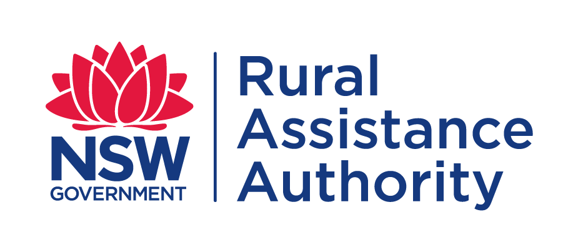

APPLICATION FORM
Natural Disaster Relief & Recovery Grant Assistance

NSW BUSHFIRES FROM 31 AUGUST 2019
Local Government Areas affected for Small Business:
CLOSING DATE: | LOCAL GOVERNMENT AREAS:
24 MAY 2020 | Armidale, Ballina, Bellingen, Byron, Clarence Valley, Coffs Harbour, Glen Innes Severn, Inverell, Kempsey, Kyogle, Lismore, Mid-Coast, Nambucca, Port Macquarie-Hastings, Richmond Valley, Tenterfield, Tweed, and Walcha
18 JUNE 2020 (EXTENSION) | Blue Mountains, Lithgow, Hawkesbury, Cessnock, Central Coast and Singleton
23 JUNE 2020 (EXTENSION) | Wingecarribee, Wollondilly
3 JULY 2020 (EXTENSION) | Bega Valley, Eurobodalla, Queanbeyan-Palerang, Shoalhaven, Snowy Monaro, Snowy Valleys and Mid-Western

To fast-track the assessment of your application,
you are encouraged to apply online at:
https://www.raa.nsw.gov.au/disaster-recovery-grant-application

If you do not have access to the internet, you can also lodge completed application forms including required documentation with the NSW Rural Assistance Authority by the following methods:
Email: rural.assist@raa.nsw.gov.au
Post: Locked Bag 23
ORANGE NSW 2800
Telephone: 1800 678 593

Applications and invoices must be received by the NSW Rural Assistance Authority no later than the closing date.
Applications and invoices received after the advertised application closing date, will not be accepted.

Have you applied previously for assistance from the NSW Rural Assistance Authority? | Yes | No
If you select ‘Yes’ please provide your 6 digit BP number, if available. | BP: 5

- ABOUT YOU
Applicant(s) Full Name(s): | Date(s) of Birth
 | / /
 | / /

Business Address:
 |  | Postcode
Local Government Area (LGA):
Phone: | Mobile:
E-mail :

Postal Address of Business: (If different to business address)
Postcode

- ABOUT YOUR SMALL BUSINESS
Business type: (Retail Bakery, travel agency)
Legal/registered name of business:
Trading name: (if different from the legal / registered name)
ABN/ACN:
Number of full time employees: | Number of part time employees:
Your role in the business: (Director, Manager, Partner)

Under normal circumstances, more than 50% of my/our total gross income is derived from the business which is claiming. | Yes | No
Is the business a publicly listed company or part of a national retail chain?  (Excludes franchises) | Yes | No
Does the business intend to resume trading / development? | Yes | No

Have you applied previously, or are you a partner, or do you have any financial involvement with any other small business applying for a Natural Disaster Relief and Recovery Grant? |  | Yes | No
If Yes, please provide details below.
Family Name:
Given Name(s):
Business Name:
Role in the business:

- Reason for claiming
Has this business suffered direct damage as a result of the NSW Bushfires from 31 August 2019? |  | Yes | No
Briefly describe the damage claimed NOT covered by insurance.
Damage covered by insurance is not eligible – for further information please refer to the guidelines https://www.raa.nsw.gov.au/grants/disaster-recovery-grants/nsw-bushfires

What is the estimated value of the damage? | $
What is the Amount of Grant applied for? (Maximum $15,000) | $
Has a claim for insurance been made as a result of the NSW Bushfires from 31 August 2019?  If yes, please provide a copy of your insurance claim |  | Yes | No
If no, please advise why a claim has not been made

- Bank Account details
Please provide bank account details for payment of grant
Account Name:
Bank/Credit Union etc Name:
BSB : | Account No:

- Contact Details
Accountant
Firm Name:
Contact Name:
Phone: | Mobile:
Email:

Rural Financial Counsellor
Counselling Service Name:
Contact Name:
Phone: | Mobile:
Email:

- Statements
General Statement
Any person who knowingly and with intent to defraud the NSW Rural Assistance Authority or another person, files an application for assistance containing any materially false information, or conceals for the purpose of misleading information concerning any fact material thereto, commits a fraudulent act, which is a crime under the Crimes Act 1900 and subjects the person to criminal penalties

Privacy Statement
The information in this application is provided voluntarily and is being collected by the NSW Rural Assistance Authority for purposes related to the administration of the scheme of assistance under which you have applied, including the assessment of the effectiveness of the scheme. This may involve disclosing the information in this application to contractors engaged by the Authority or to either State or Commonwealth government agencies. We will supply you with details of those that we have disclosed information to, if you apply to us in writing. Information regarding your application may also be discussed and exchanged with the nominated contact persons listed by you in your application.
Not providing the information requested in this application or providing false or misleading or incomplete information may impact on the ability of the Authority to accurately assess your application.
The NSW Rural Assistance Authority agrees to take all reasonable measures to ensure that the personal information collected by it is stored securely.
You may access or correct your personal information by contacting the Authority by telephone on 1800 678 593 (toll free) or by writing to: Manager Administration, NSW Rural Assistance Authority, Locked Bag 23, ORANGE, NSW, 2800. Calls to “1800” numbers from your home phone are free. Calls from public phones and mobiles may be timed and attract charges

Your statement
I/We understand and declare that:
- I have read, understood and I will comply with the scheme guidelines.
- The information I have provided in this application is true and correct.
- If I am applying on behalf of a partnership, trust or corporation, I have the authority to make this application on its behalf.
- The business listed in this application:
    - suffered direct damage as a result of the NSW Bushfires from 31 August 2019, and
    - is an eligible business.
- It is intended that the business will be re-established within the affected area.
- Any overpayment will be recovered.
- I/We have made a claim for insurance where eligible, or insurance has been refused or the payout does not cover all costs, and proof of this claim is attached.
- When asked for financial information, I must provide my personal tax returns in addition to financial information for all business entities with which I have a formal interest including companies, partnerships and self-managed super funds.
- The invoices for this application have not been used to secure any other NSW government funding. (i.e. I have not been reimbursed for these invoices in the past).
- I authorise RAA to discuss this application with relevant private/public authorities, financial lending institutions and accountants, including my nominated financial counsellor/advisor. If required, I will provide documents from the relevant authority to permit the RAA to do this.
- Any assistance received under this scheme will be applied in accordance with the scheme guidelines and the RAA may conduct an audit or inspection to ensure I have complied.
- I have obtained/will obtain all required work approvals and permits prior to commencing work, and I understand the need for any development to be ecologically sustainable.
- I will provide feedback in relation to this scheme if requested.
- Any statistics collected and analysed will be done in such a way to protect my anonymity.
- The NSW Rural Assistance Authority can make relevant enquiries to ensure I receive my correct entitlement.
- Prior to applying for this assistance I/we sought independent financial advice and the taxation implications of any assistance granted has been explained to me.
- Statistics may be collected and analysed in such a way as to protect my anonymity.
- I/We agree to provide feedback in relation to this Scheme.
Signed: _______________________ Signed: ________________________
Name: _______________________ Name: ________________________
Date: ____ / _____ / ________ Date: ____ / _____ / _______

If you have difficulty understanding or completing this form you should seek the assistance of your rural/financial counsellor, business advisor, accountant or a trusted family member/friend.
Language Services (Interpreting and Translating) are available by contacting Multicultural NSW on
1300 651 500 or by visiting languageservices@multicultural.nsw.gov.au.

To avoid any delay in the processing of your application,
please ensure you have provided all the information listed below.

CHECK LIST

Proof of business registration
- Copy of current registration certificate
Proof of business location
- Copy of last rates notice, gas bill, electricity bill, phone bill or lease agreement
Proof of income
- Business Taxation Returns and Financial Statements plus Personal Tax Returns of all members of the Business.
Tax assessments are not acceptable
Do not send original Tax Returns
Proof of expenditure
- Copies of Tax Invoice/ Receipts of expenditure incurred to date
(can be supplied post assessment)
No payments will be made on quotations

Proof of Insurance
- Copy of Insurance Claim (if applicable)

