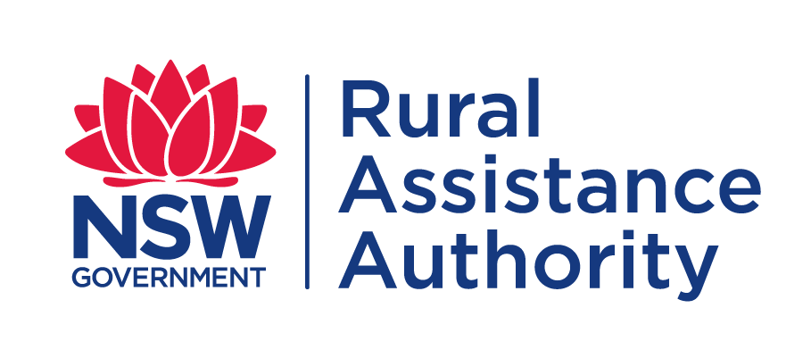 | CLAIM FORM  TRANSPORT SUBSIDY  FOR NATURAL DISASTER
Submit all claim forms with certified copies of invoices. Initial claims MUST be submitted no more than 6 months after the first movement with the first movement to take place during the first 3 months of a Natural Disaster declaration.
Note: Drought is no longer a declared Natural Disaster
Have you applied previously for assistance from the NSW Rural Assistance Authority? |  | Yes | No
NOTE: If you select ‘Yes’ please provide your 7-digit BP number, if available. | BP: 2 5

- ABOUT YOU
Applicant(s) Full Name(s) : |  |  | Date(s) of Birth
 |  |  | / /
 |  |  | / /
Full Property Address:
 |  | Postcode
Local Government Area (LGA) of property:
Local Land Service (LLS) of property:

Please attach copy of latest LLS and LGA rates notices

Postal Address (If different to property address)
 |  |  | Postcode
Phone: | Mobile: | Fax :
E-mail :

- ABOUT YOUR PRODUCTION ENTERPRISE
Trading name (if different from the legal / registered name):
ABN: | ACN:
Assessed carrying capacity:

- REASON FOR CLAIMING
Has this business suffered direct damage as a result of a declared Natural Disaster event? | Yes No
If so, which Natural Disaster event has affected your operations?
Drought is no longer a declared Natural Disaster
What was the Month/Year of the disaster?

Is this claim for:  (please tick) | Road transport of stock from a disaster affected area to areas of agistment | Yes No
 | Road transport of stock from agistment to a previous disaster affected area | Yes No
 | Road transport of fodder to a disaster affected area | Yes No
 | Road transport of water to a disaster affected area | Yes No
 | Road transport of stock to sale or slaughter | Yes No
Particulars of Transportation costs
Movt No | Date Loaded | Movement Type  (eg- to agist, from agist, fodder etc) | Net Weight or Litres of water or No of stock transported | Amount paid to Carrier | Distance Carried (km) | Cost per km | Subsidy amount 50% (ex GST)
1 | / / |  |  | $
2 | / / |  |  | $
3 | / / |  |  | $
4 | / / |  |  | $
5 | / / |  |  | $
 |  |  |  |  |  | TOTAL

If owner carrier please supply copy of vehicle registration papers and log book entries

Please provide evidence of purchase (fodder/water) and/or confirmation of agistment

Particulars of Movements
Movt No | Carriers name | Movement from | LLS district | Movement to | LLS district
1
2
3
4
5

In case of interstate movement indicate NSW border crossing point

Particulars of stock and fodder on hand
Number of stock on hand: Sheep/Goats/Deer Dairy Cattle Beef Cattle
Fodder on hand prior to arrival of fodder referred to on this form (nearest tonne):
Hay Grains Other

- BANK ACCOUNT DETAILS
Please provide bank account details for payment of grant
Account Name :
Bank/Credit Union etc Name :
BSB : | Account No:

- CONSENT FOR RELEASE OF INFORMATION
I/We have lodged a claim with the NSW Rural Assistance Authority for a transport subsidy in relation to . (declared Natural Disaster event).

To allow this claim to be assessed, I/we authorise the release of information by relevant authorities, including Commonwealth, state/territory or local authorities to the NSW Rural Assistance Authority relating to (declared Natural Disaster event) and being claimed for in this form.

Signed: _______________________ Signed: ________________________
Name: _______________________ Name: ________________________
Date: ____ / _____ / ________ Date: ____ / _____ / _______

- STATEMENTS
General Statement
Any person who knowingly and with intent to defraud the NSW Rural Assistance Authority or another person, files an application for assistance containing any materially false information, or conceals for the purpose of misleading information concerning any fact material thereto, commits a fraudulent act, which is a crime under the Crimes Act 1900 and subjects the person to criminal penalties

Privacy Statement
The information in this application is provided voluntarily and is being collected by the NSW Rural Assistance Authority for purposes related to the administration of the scheme of assistance under which you have applied, including the assessment of the effectiveness of the scheme. This may involve disclosing the information in this application to contractors engaged by the Authority or to either State or Commonwealth government agencies. We will supply you with details of those that we have disclosed information to, if you apply to us in writing. Information regarding your application may also be discussed and exchanged with the nominated contact persons listed by you in your application.
Not providing the information requested in this application or providing false or misleading or incomplete information may impact on the ability of the Authority to accurately assess your application.
The NSW Rural Assistance Authority agrees to take all reasonable measures to ensure that the personal information collected by it is stored securely.
You may access or correct your personal information by contacting the Authority by telephone on 1800 678 593 (toll free) or by writing to: Manager Administration, NSW Rural Assistance Authority, Locked Bag 23, ORANGE, NSW, 2800.
Calls to “1800” numbers from your home phone are free. Calls from public phones and mobiles may be timed and attract charges

Your statement
I understand and declare that:
- I have read, understood and I will comply with the scheme guidelines.
- The information I have provided in this application is true and correct.
- If I am applying on behalf of a partnership, trust or corporation, I have the authority to make this application on its behalf.
- The business meets the criteria for an eligible business for the scheme.
- When asked for financial information, I must provide my personal tax returns in addition to financial information for all business entities with which I have a formal interest including companies, partnerships and self-managed super funds.
- The invoices for this application have not been used to secure any other NSW government funding. (i.e. I have not been reimbursed for these invoices in the past).
- I will be required to repay any overpayment I receive.
- I authorise RAA to discuss this application with relevant private/public authorities, financial lending institutions and accountants, including my nominated financial counsellor/advisor. If required, I will provide documents from the relevant authority to permit the RAA to do this.
- Any assistance received under this scheme will be applied in accordance with the scheme guidelines and the RAA may conduct an audit or inspection to ensure I have complied.
- I have obtained/will obtain all required work approvals and permits prior to commencing work, and I understand the need for any development to be ecologically sustainable.
- I will provide feedback in relation to this scheme if requested.
- Any statistics collected and analysed will be done in such a way to protect my anonymity.

Signed: _______________________ Signed: ________________________
Name: _______________________ Name: ________________________
Date: ____ / _____ / ________ Date: ____ / _____ / _______

- LODGEMENT OF APPLICATIONS

Applicants can lodge completed application forms including required documentation with the NSW Rural Assistance Authority by post, email, facsimile or personal delivery at:

Post: Locked Bag 23
Orange NSW 2800

Email: rural.assist@raa.nsw.gov.au

Fax: (02) 6391 3098

In person: 105 Prince Street
Orange NSW 2800

Telephone: 1800 678 593 (Toll Free)

Website: www.raa.nsw.gov.au

Applications must be received by the NSW Rural Assistance Authority no later than the closing date. Applications received after the advertised application period closing date,
in any other circumstances will not be accepted.

If you have difficulty understanding or completing this form you should seek the assistance of your rural/financial counsellor, business advisor, accountant or a trusted family member/friend.
Language Services (Interpreting and Translating) are available by contacting Multicultural NSW
on 1300 651 500 or by visiting languageservices@multicultural.nsw.gov.au.

To avoid any delay in the processing of your application,
please ensure you have provided all the information listed below.

CHECK LIST

Proof of property location
(Copy of latest Local Land Service (LLS) and Local Government Area (LGA) rates notices)
Owner Carrier
(Copy of registration papers and log book entries)
Proof of Expenditure (Tax Invoice)
Have all parties signed and dated the Application Form (Pages 2 & 4)?

